**Crude Oil Flash Calculator User Guide**

Thomas Manuel Ortiz, Ph.D., P.E.

Last Updated on July 19, 2019

**Overview**

The GLO Crude Oil Flash Calculator tool allows auditors to verify the theoretical quantity of stock tank oil and flash gas obtainable from a volume of crude oil at known temperature and pressure. The tool encapsulates the underlying engineering science—including interoperability with the DWSIM Standalone Thermodynamics Library—into a suite of Python scripts that are stored securely on the GLO network. The Excel interface relies on the scripts to calculate results, and it must be run on the network.

**Installation and Access**

The tool is accessed and executed from O:\AUDIT_TOOLS directory.

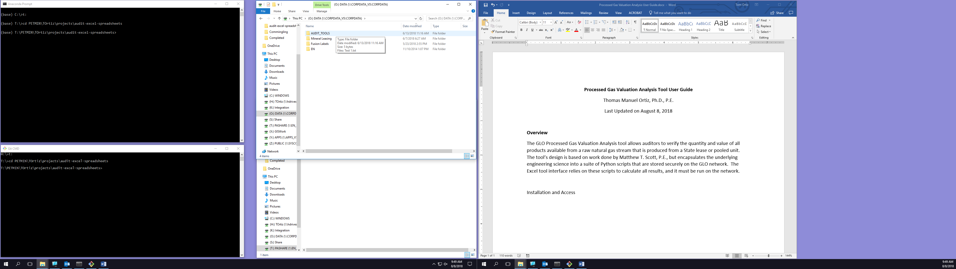

Inside this directory you will see the following items: a shortcut to a macro-enabled Excel spreadsheet, and two directories. One of the directories is hidden, and if you do not have Show Hidden Files enabled on your computer, you may not see src, which is fine. You will never need to access the src directory.

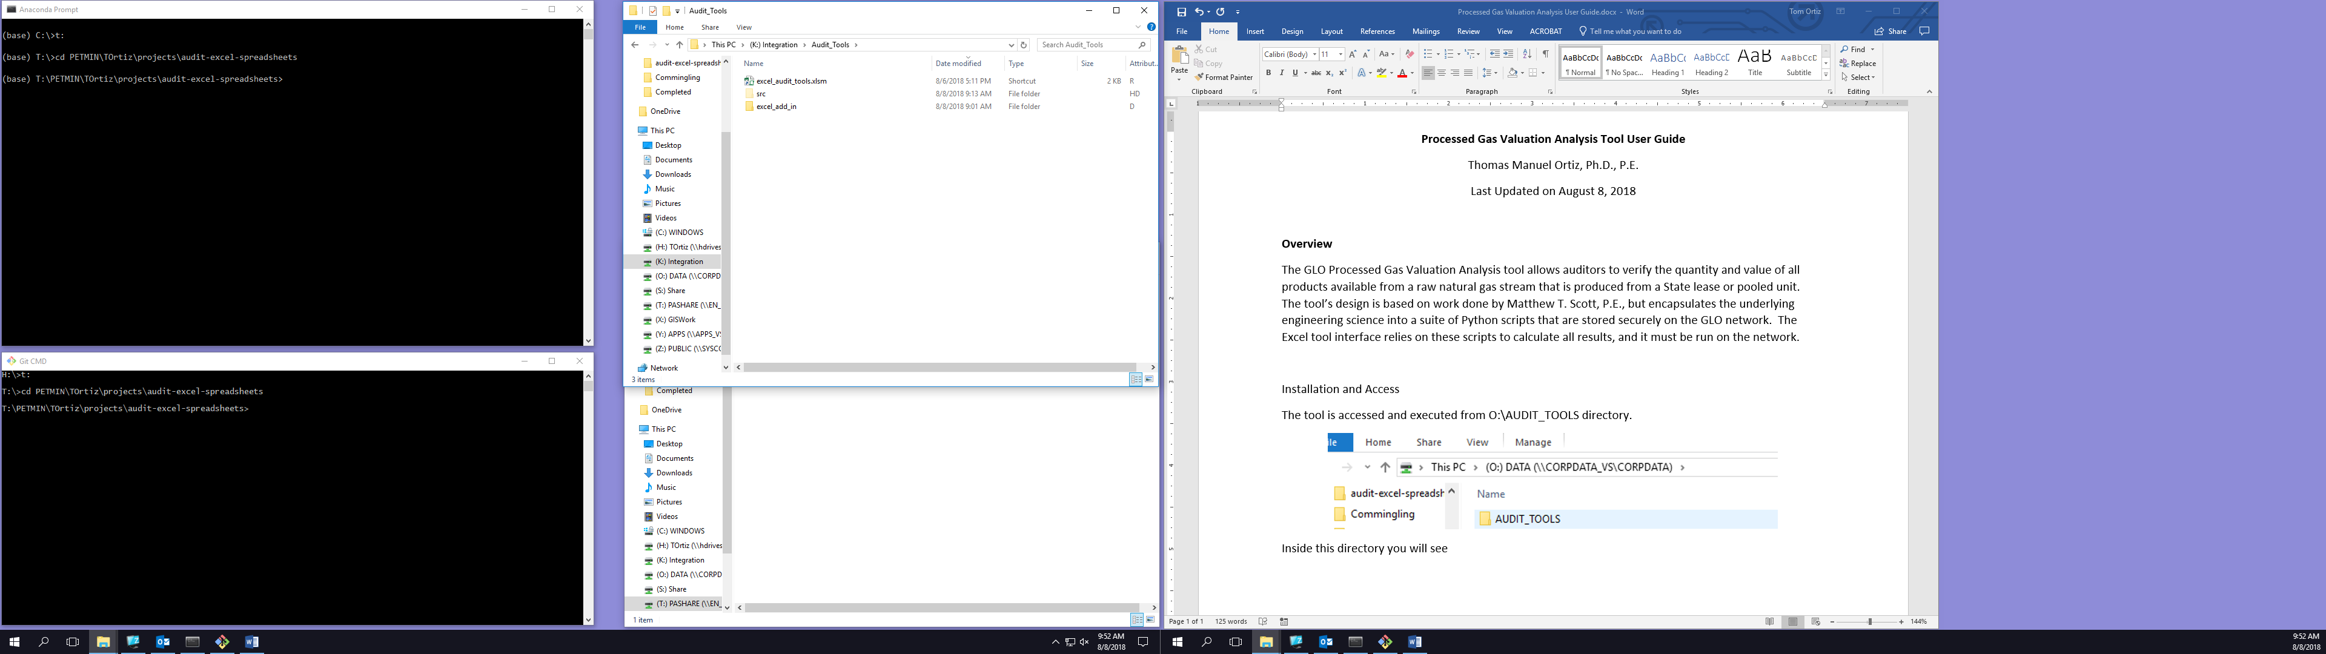

Open Microsoft Excel on your computer, and navigate to the Developer tab.

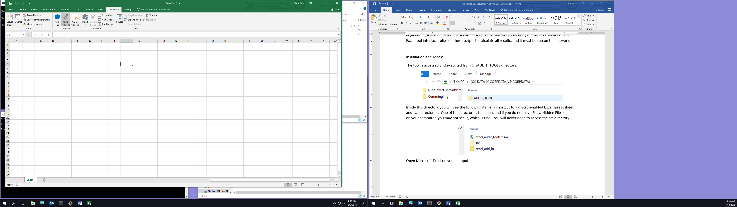

Click on the Excel Add-ins button in the Ribbon. The Add-ins dialog will appear. Click Browse.

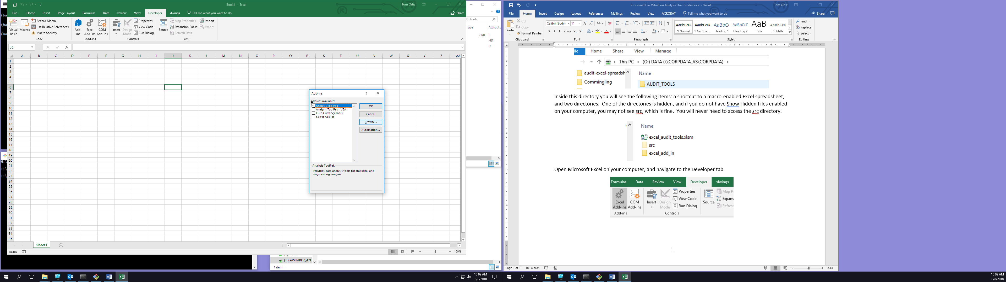

Browse to O:\AUDIT_TOOLS\excel_add_in and choose xlwings.xlam to install the add-in to Excel.

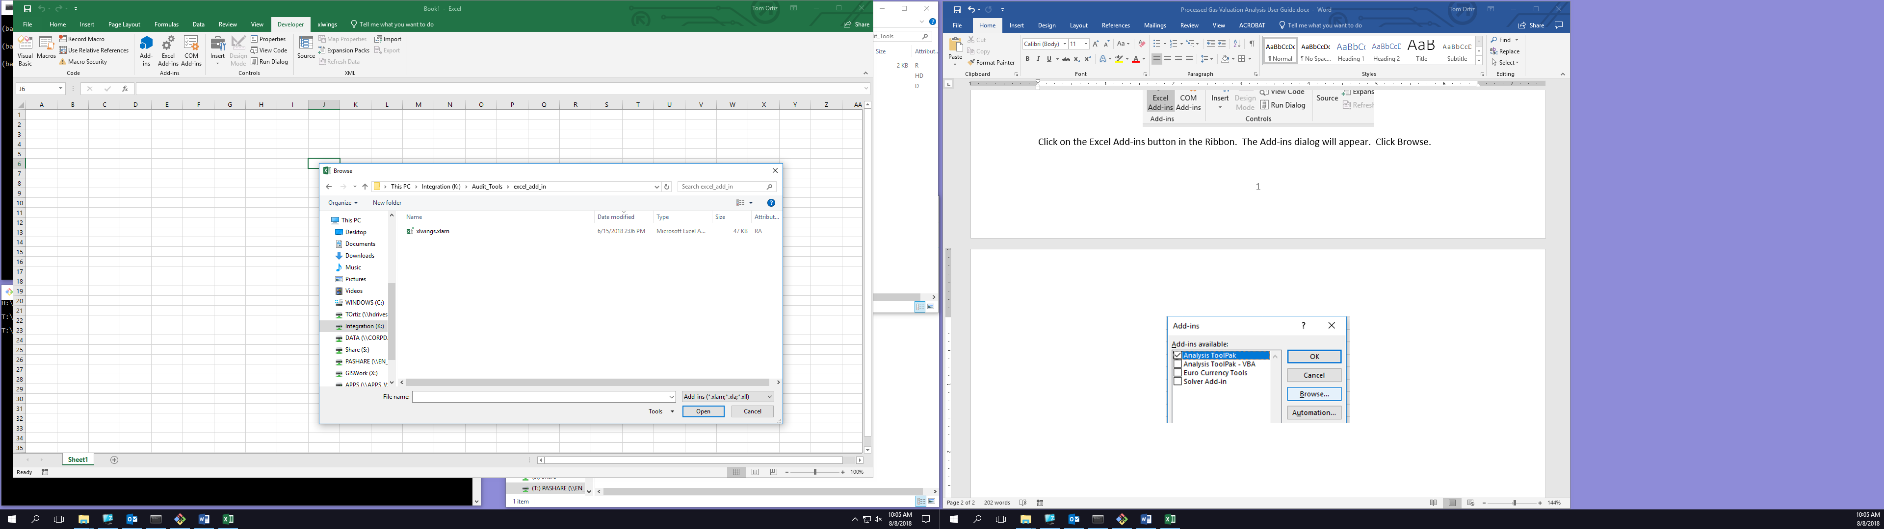

There is nothing else for you to install. You may have to restart Excel to see the new xlwings tab.

**NOTE:** If you already have a copy of the xlwings add-in installed, you should uninstall it and install the latest version from O:\AUDIT_TOOLS\excel_add_in.

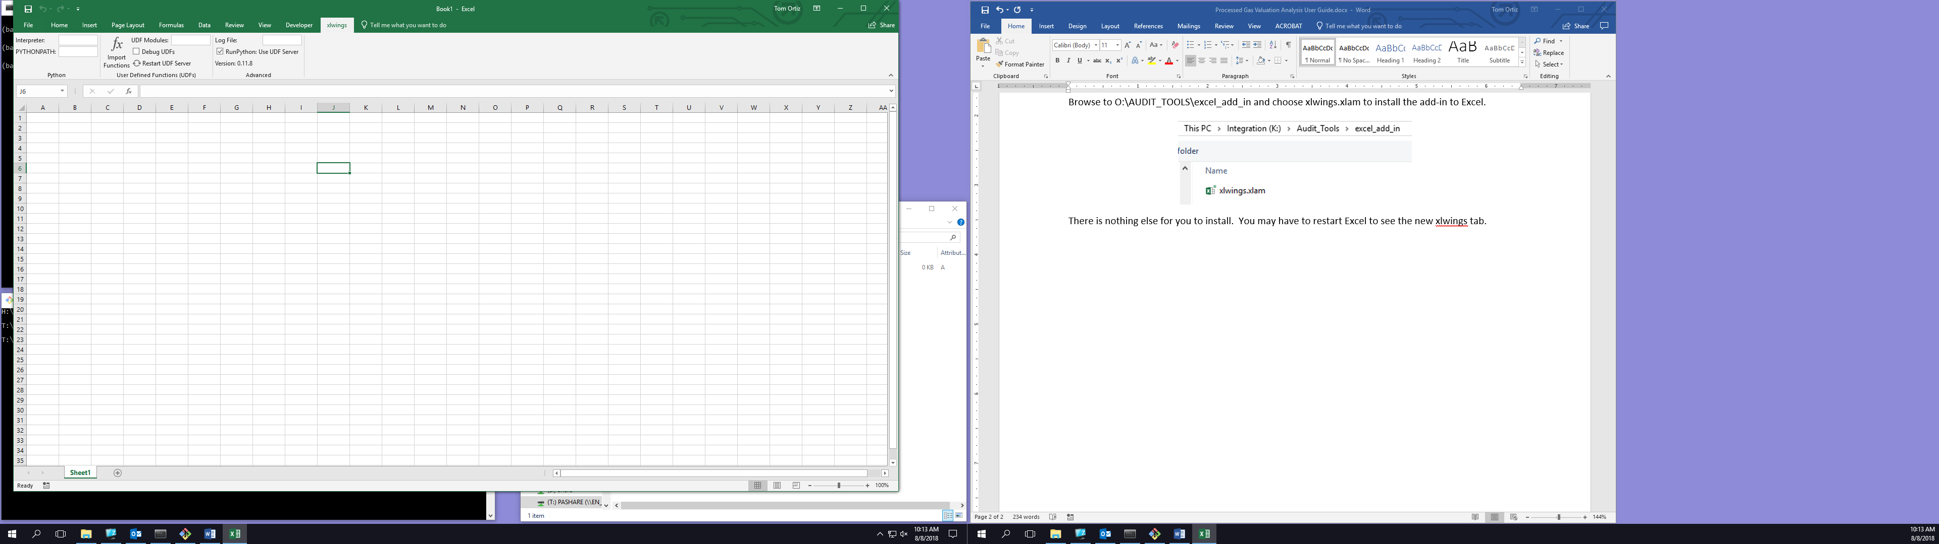

Be sure the xlwings tab is configured exactly as shown above.

Double-click on the shortcut O:\AUDIT_TOOLS\excel_audit_tools.xlsm to open the tool in Excel.



Once the file is open in Excel, navigate to the xlwings tab and click Import Functions.



Once Import Functions finishes running, you are ready to use the tool.

**Entering Input Data**

Administrative information about the lease can be entered at the top of the worksheet. This information is not needed to run the tool, and it may therefore be left blank if desired.

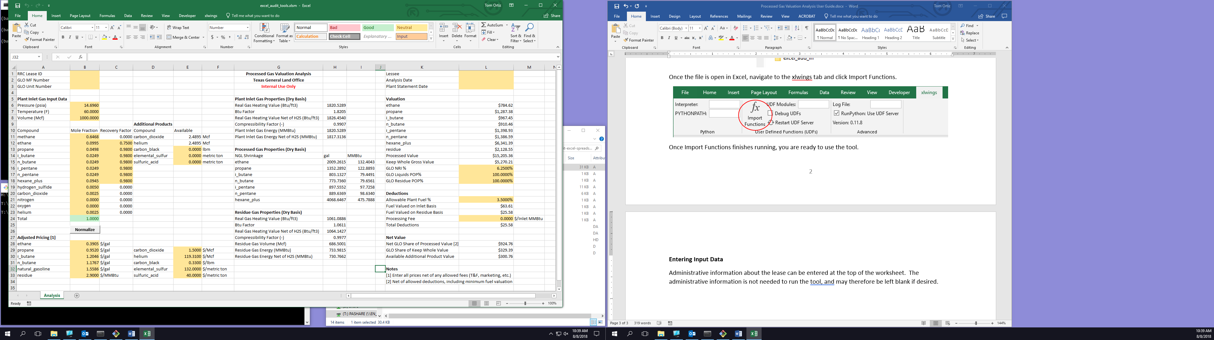

Crude oil input data will come from reports submitted by lessees. The following example illustrates the relationship among the input data and where it would be found in a sample crude oil lab report.

**NOTE:** The volume of crude oil must be stated at (i.e. must correspond to) the input pressure and temperature. The input crude oil is *not* stock tank oil!

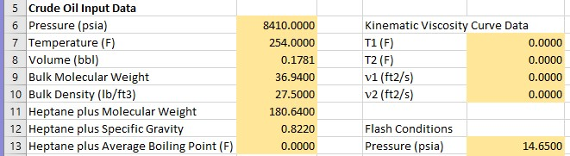

**6**

**5**

**4**

**2**

**3**

**1**

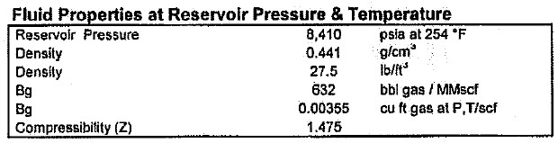

**3**

**2**

**1**

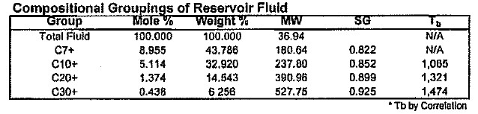

**8**

**C7 = Heptane**

**6**

**4**

**5**

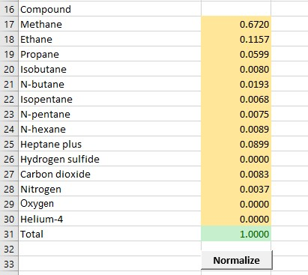

**7**

**8**

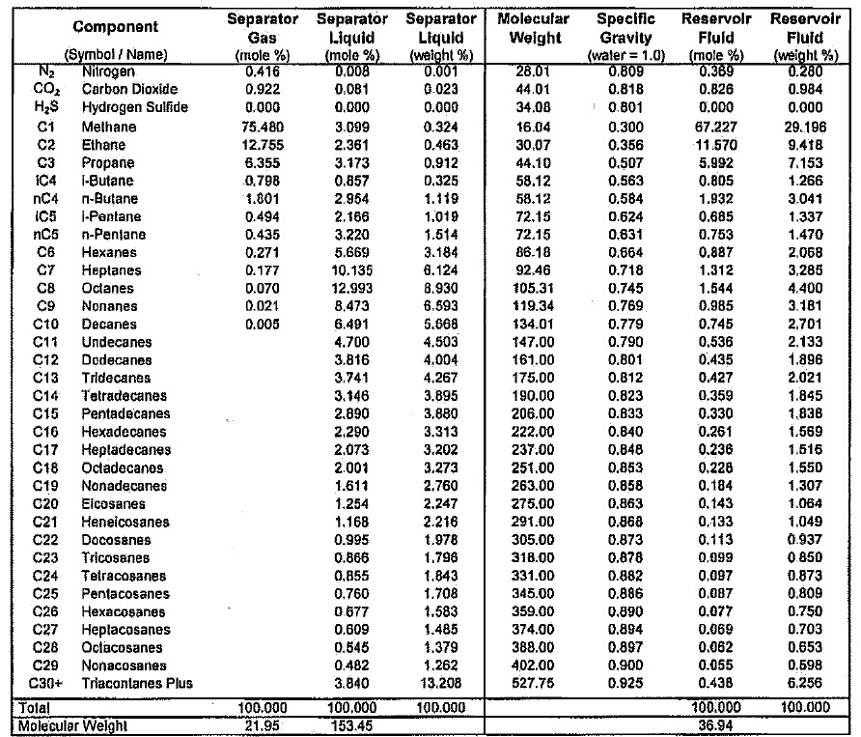

**7**

**NOTE:** Normalization of your composition may rebalance (i.e. change) your mole fractions slightly.

**IMPORTANT:** If you do not have data to enter in a field, such as “Heptane plus Average Boiling Point” or “Kinematic Viscosity Curve Data”, then it must be left as 0.0000 or else the tool may not run properly.

The example shown above represents the minimum amount of data that should be used to run the crude oil flash calculation. If you also have a C7+ average boiling point (sometimes also called normal boiling point, or NBP), and/or viscosity curve data, then your calculation accuracy may improve.

Flash conditions are the initial and final temperatures and pressures for each successive stage of separation, and correspond to the successive separator, heater treater or other oil stabilization vessels through which the crude oil flows from wellhead to stock tank.

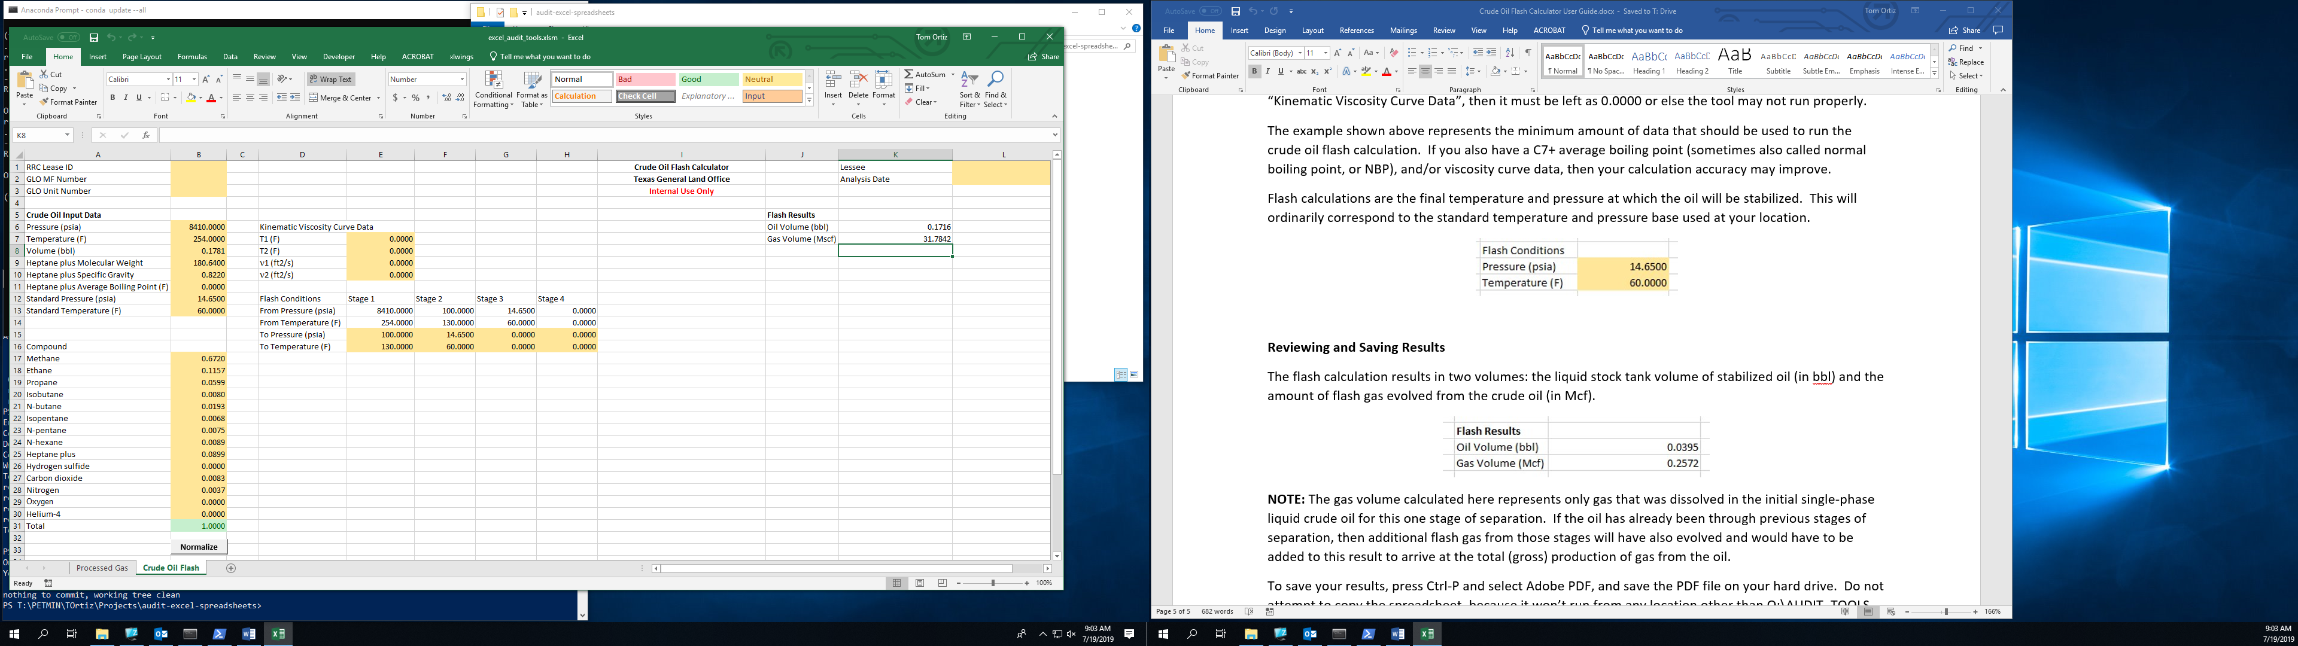

**NOTE:** You only enter the “To” (i.e. outlet) temperature and pressure values for each stage/vessel. The “From” values will be populated automatically.

**IMPORTANT:** The “To Pressure” and “To Temperature” fields for unused stages must be left as 0.0000.

Finally, enter the standard temperature and pressure. These values will be used to convert all gas volumes to standard volumes in Mscf (thousand standard cubic feet). They will correspond to the temperature and pressure base appropriate for your location.

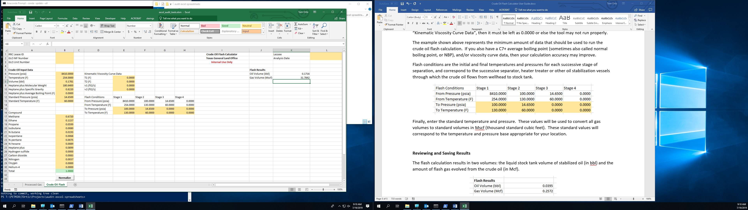

**Reviewing and Saving Results**

The flash calculation results in two volumes: the liquid stock tank volume of stabilized oil (in bbl) and the amount of flash gas evolved from the crude oil (in Mcf).

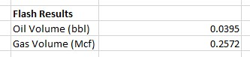

**NOTE:** The gas volume calculated here represents only gas that was dissolved in the initial single-phase liquid crude oil for this one stage of separation. If the oil has already been through previous stages of separation, then additional flash gas from those stages will have also evolved and would have to be added to this result to arrive at the total (gross) production of gas from the oil.

To save your results, press Ctrl-P and select Adobe PDF, and save the PDF file on your hard drive. Do not attempt to copy the spreadsheet, because it won’t run from any location other than O:\AUDIT_TOOLS.